**Software Quality Assurance Project**

**Performance Testing:**

Website link: <https://www.alibaba.com/>

**1):Thread group**

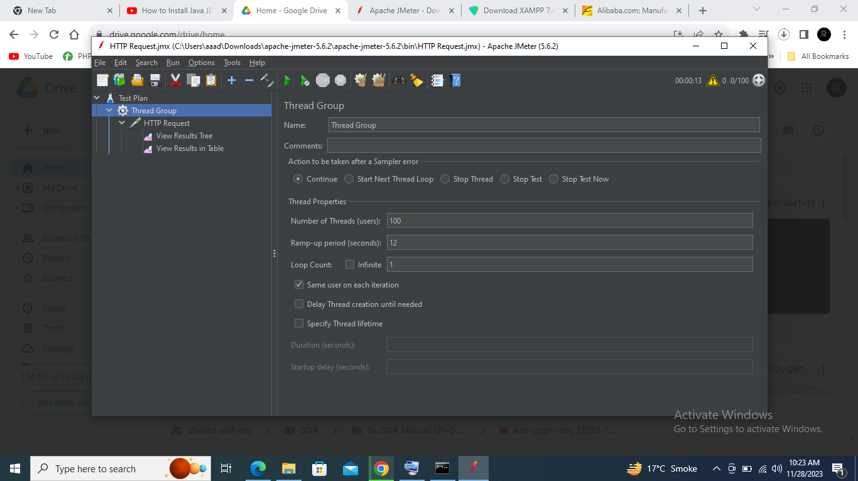

**2): Http request:**

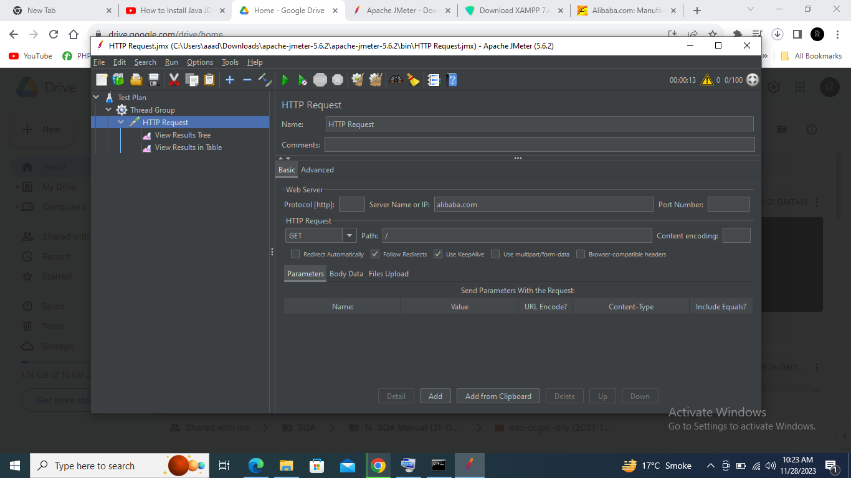

**3):View Results Tree**

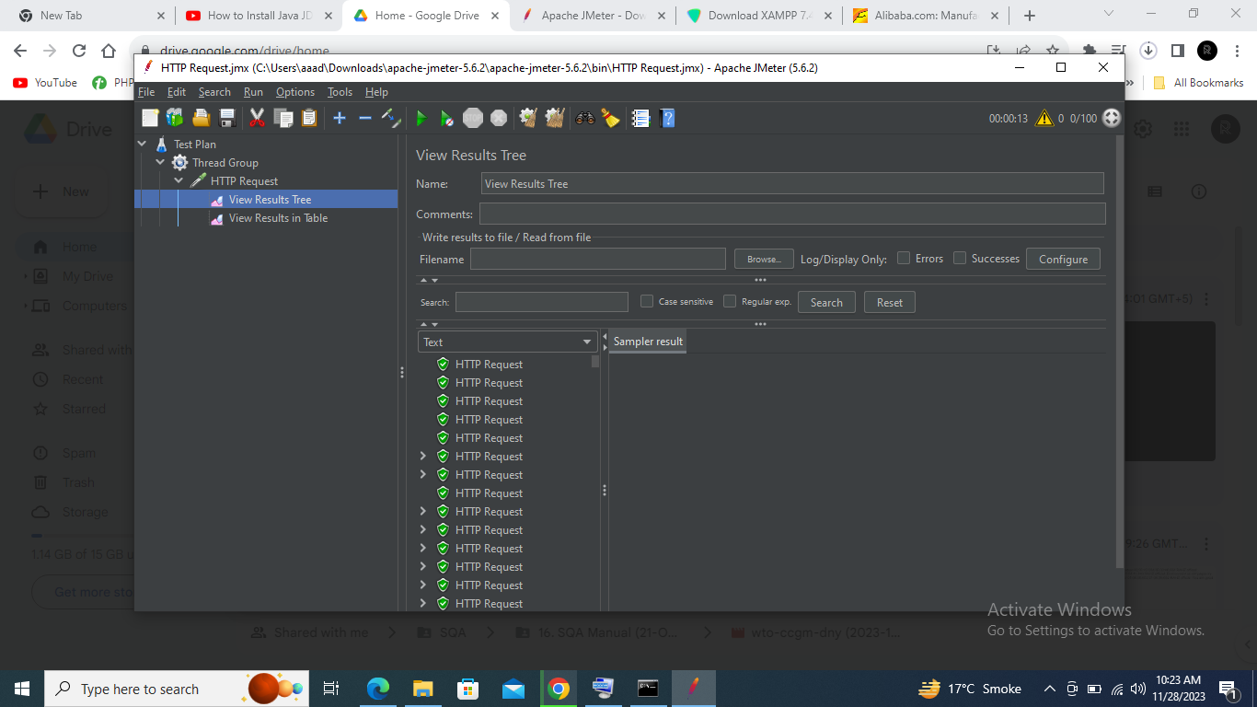

**4): View Results Table:**

